B.C.M. Sen. Sec. School, Basant City, Pkh. Road, Ludhiana
Name ___________________ Roll No._____ Standard II
Chapter (2, 3)
- Colour the mouse buttons according to the colour given.
      - Left Button: Blue
      - Right Button: Orange
      - Scroll Wheel: Pink
      - Mouse Body: Yellow

- Given below are the qualities of man and computer, colour the qualities of computer with Green colour and that of man with Red colour
Can thick
Can feel
Take Decision
Fast

More Storage
Accurate
Tireless
Intelligent
Use electricity

- Follow the directions given below and colour the picture with your crayons.
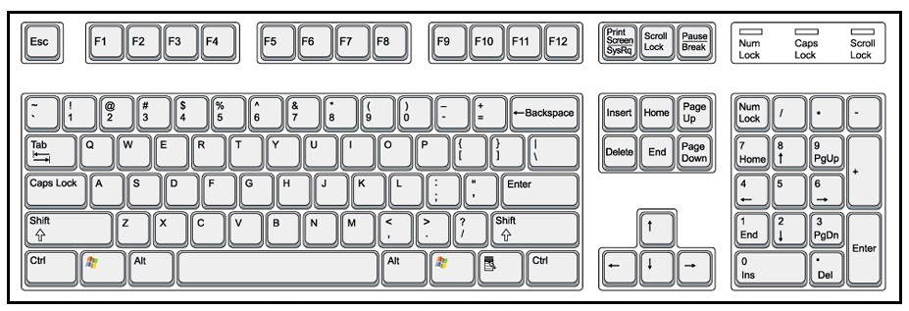
- Keys that spell your name and surname. (use Orange colour)
- Key which adds space between your name and surname. (use Red colour )
- This is your Eraser. (use Green colour)
- Keys which type your Age. (use Blue colour)

- True/False
T
F
F
T
T
- You can play games on computer.
- We use the Caps Lock key to type small letters.
- Computer does not help in the school library.
- The Backspace key works like an eraser.
- Scroll mouse has a scroll wheel in the middle of two buttons.

- Answer the following questions.
- What is the use of computer at railway station?
Ans. Reservation and cancellation of tickets
- Name the five mouse actions.
Ans. Click, Drag, Double-Click, Right-Click, Scroll.
- What is Robot?
Ans. A robot is a machine.
- Name the special keys.
Ans. Caps Lock Key, Backspace Key, Enter Key, Spacebar Key, Control Key
- What is a mouse?
Ans. A mouse is a pointing device.
- Match the following:
Alphabet Keys | 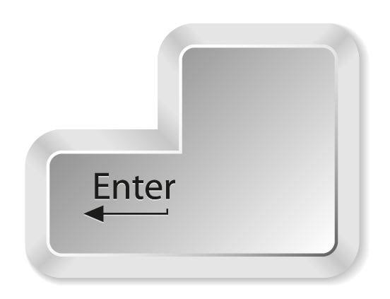
Space Bar Key | 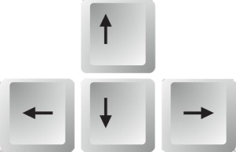
Number Keys | 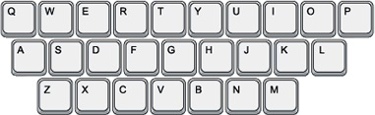
Arrow Keys | 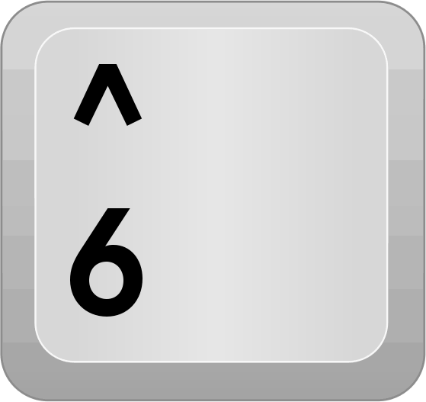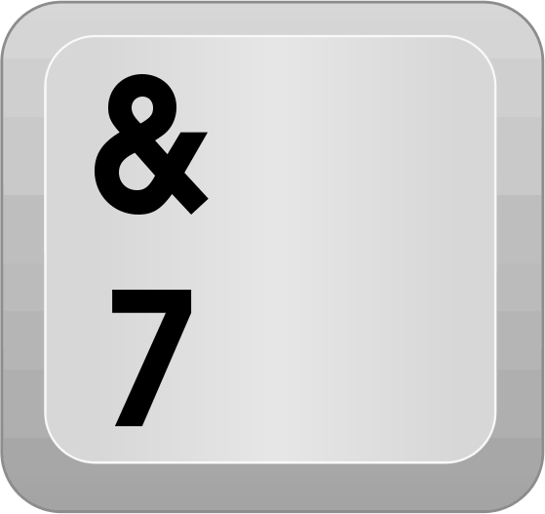
Backspace Key
Enter Key

